Section A

Project Overview — COVID-19 Data Analytics Project

- This project analyzes India’s COVID-19 pandemic data to understand how the virus spread across different states and time periods.
- It combines multiple datasets covering confirmed cases, recoveries, deaths, vaccination progress, and testing statistics
- Perform ETL (Extract, Transform, Load) processes using SQL to clean, structure, and integrate COVID-19 data.
- The transformed data will be analyzed in Excel to identify pandemic trends, vaccination impact, and testing effectiveness.
- The final deliverable is an interactive Excel dashboard that visually explains COVID-19 patterns and supports data-driven insights.
- The project emphasizes real-world analytical skills such as data cleaning, trend analysis, KPI creation, and visual storytelling using pandemic data.

Objective — COVID-19 Data Analytics Project
- To understand and implement the end-to-end data analytics process using real COVID-19 datasets from India.
- To perform data extraction, cleaning, and transformation using SQL for accurate and reliable analysis.
- To integrate multiple datasets (cases, vaccinations, and testing) into a single structured format.
- To analyze pandemic trends such as confirmed cases, recovery rates, death rates, testing activity, and vaccination progress across states and time periods.
- To develop skills in data visualization and dashboard creation using Excel.
- To present insights through an interactive dashboard that supports clear storytelling.

Section 2: ETL Phase (SQL)
This section explains the complete ETL (Extract, Transform, Load) process performed using PostgreSQL to prepare the COVID-19 dataset for analysis. The main objective of this phase was to build a clean, reliable, and structured dataset by importing raw CSV files, cleaning the data, performing transformations, and generating a final summary table.
The entire process was done using PostgreSQL SQL queries.
Link:https://drive.google.com/file/d/127l6IVL5hDEpqm_mXuCM2p6ib0atlTEO/view?usp=sharing
The following three datasets were used:
- covid_19_india – Contains daily COVID cases
- covid_vaccine_statewise – Contains vaccination data
- StatewiseTestingDetails – Contains testing data

2.1 Extract Phase – Creating Tables and Loading Data

Creating Staging Tables
First, staging tables were created to load the raw CSV data exactly as it is. All columns were defined as TEXT because raw data may contain missing values, symbols, or inconsistent formats.
Three staging tables were created:
- covid_19_india_staging
- covid_vaccine_statewise_staging
- statewisetestingdetails_staging
These staging tables act as temporary storage for raw data.
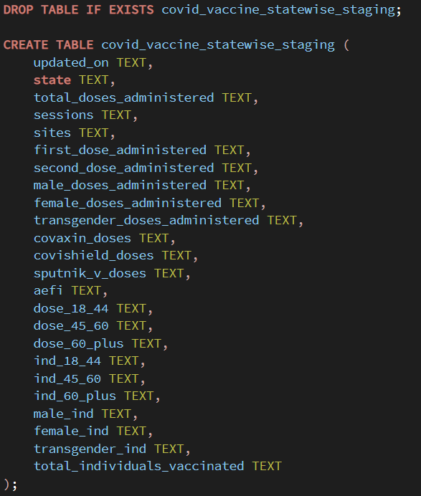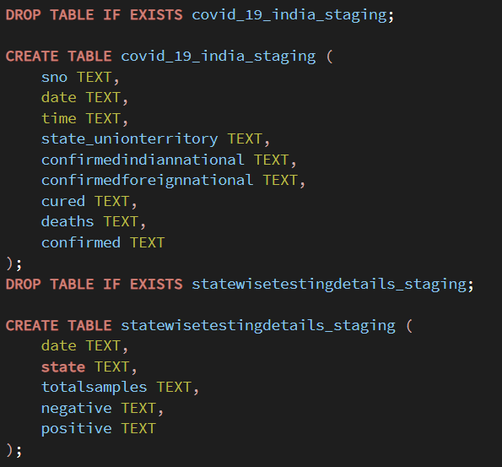

Creating Final Production Tables
After staging tables, final production tables were created with proper data types such as:
- INT for numeric values
- DATE for date columns
- BIGINT for large numeric values
- VARCHAR for text fields

Production tables created:
- Covid_19_india
- Covid_vaccine_statewise
- statewisetestingdetails
These tables store cleaned and structured data.
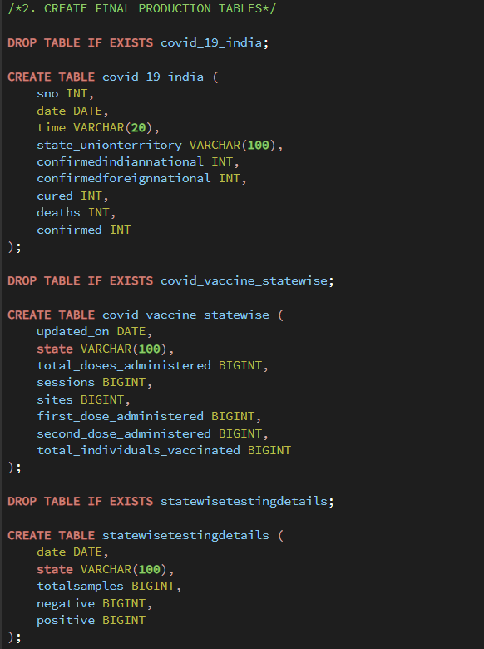

Loading Data into Final Tables
Data was loaded from staging tables into production tables using INSERT INTO SELECT statements.
During this step:
- TEXT values were converted into correct numeric types
- Dates were converted into DATE format
- NULL and missing values were handled using NULLIF
- State names were trimmed using TRIM
This step ensures clean and structured data.
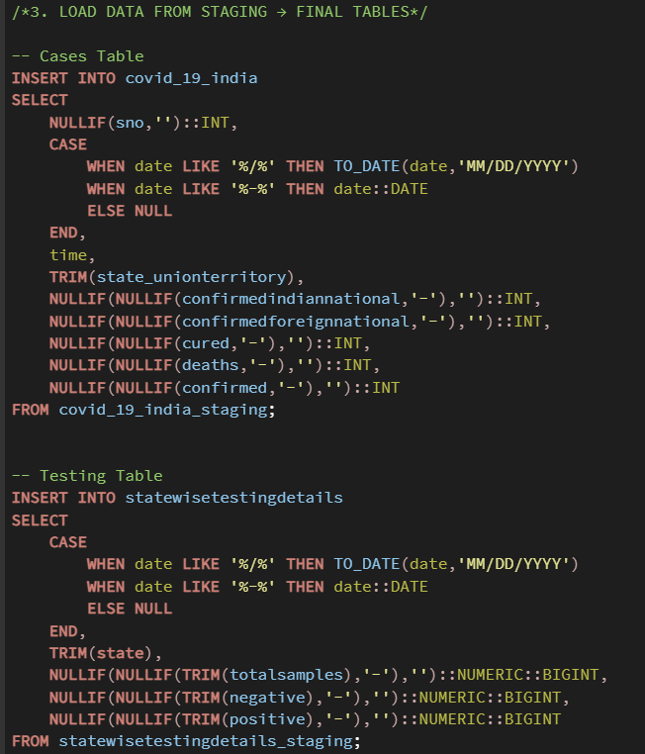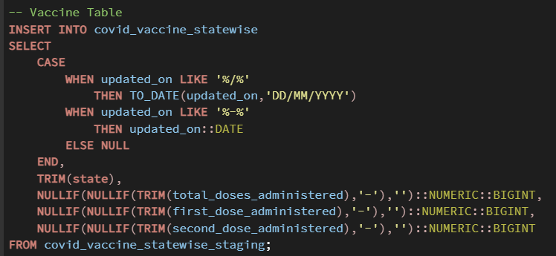

Data Validation
After loading the data, record counts were verified using COUNT(*) to ensure data was properly loaded. This confirms:
- No data loss
- Successful loading
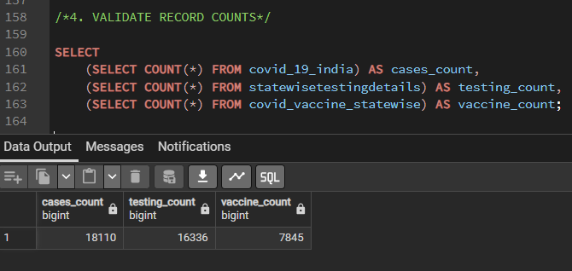

Data Preview
The first 10 rows of each table were displayed using SELECT * LIMIT 10.
This was done to verify:
- Correct data loading
- Correct column values
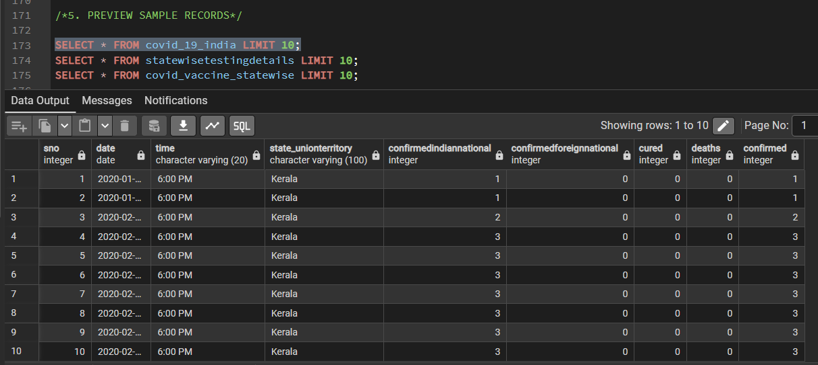
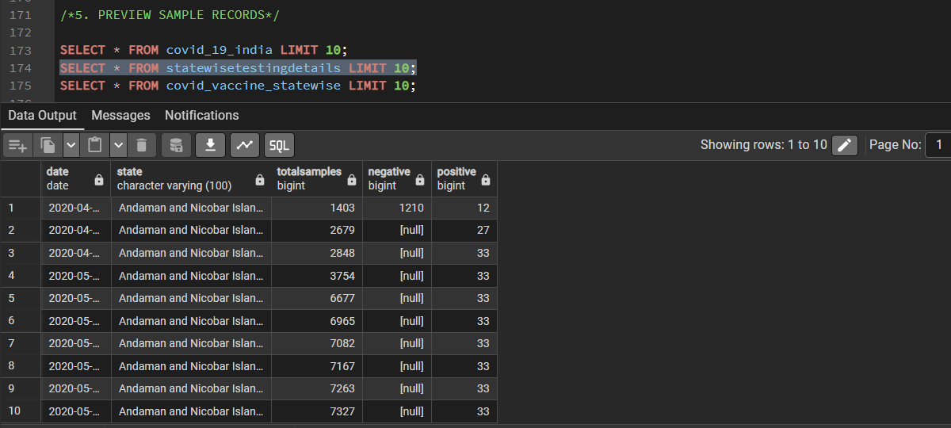
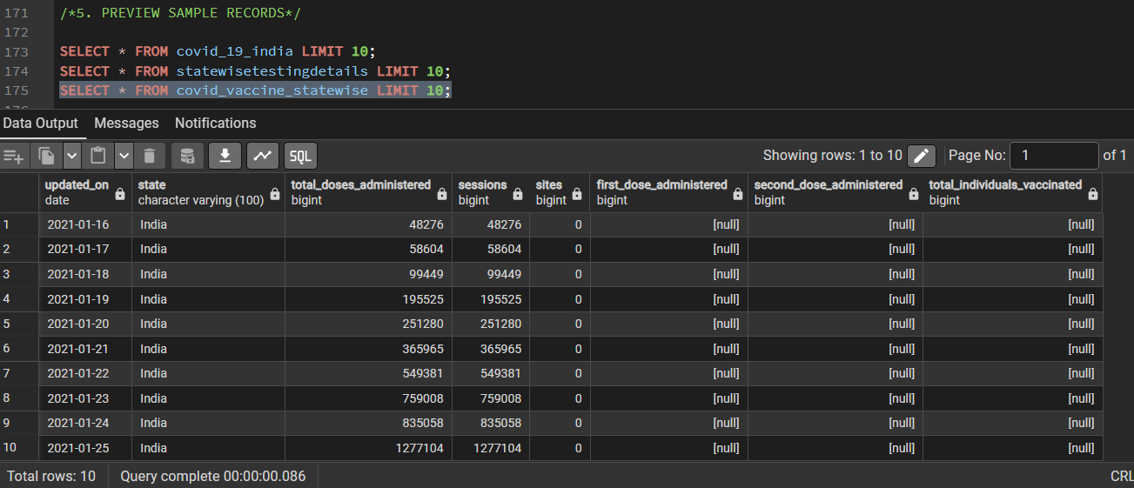

2.2 Data Cleaning Phase

State Name Standardization
Some state names were inconsistent due to spelling differences.
Example issues:
- Karanataka → Karnataka
- Telengana → Telangana
- Himanchal Pradesh → Himachal Pradesh
These were corrected using UPDATE queries.
This ensures proper joining between tables.
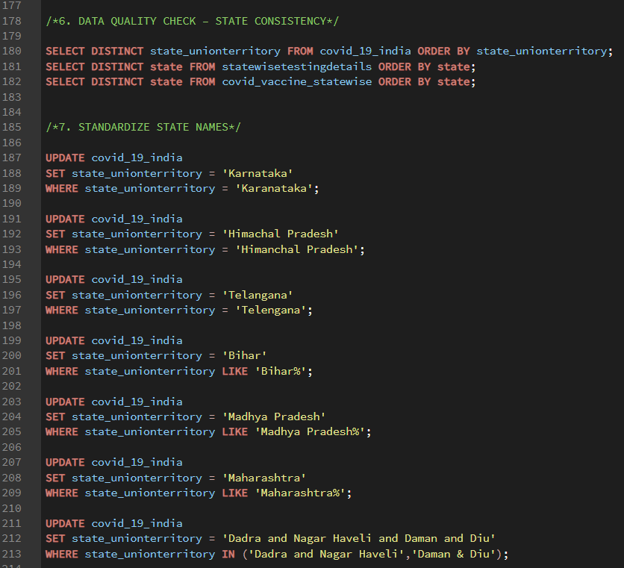

Removing Unnecessary Records
Some unwanted records like:
- Unassigned
- Cases being reassigned
- India (from vaccine dataset)
were removed using DELETE queries.
This ensures only valid state-level data is used.

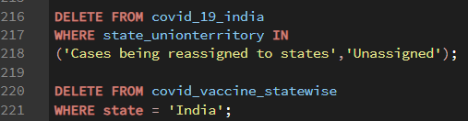

Date Standardization
Dates were converted into standard format (YYYY-MM-DD) using the TO_DATE function during table creation.
This ensured that the date column was stored in the proper DATE data type, allowing accurate 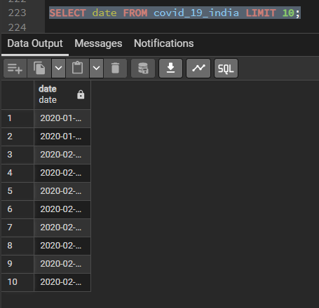

Missing Data Analysis
NULL values were checked in important columns such as:
- Confirmed
- Deaths
- TotalSamples
- Total Doses Administered
Missing values were found mainly in early pandemic stages where data was not recorded.
This was expected and handled during transformation.
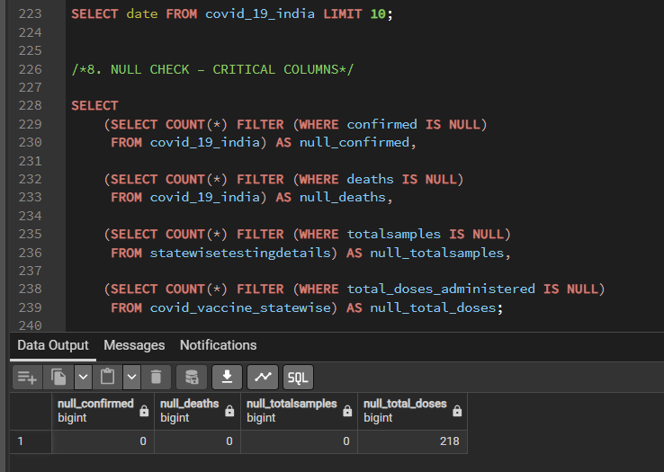
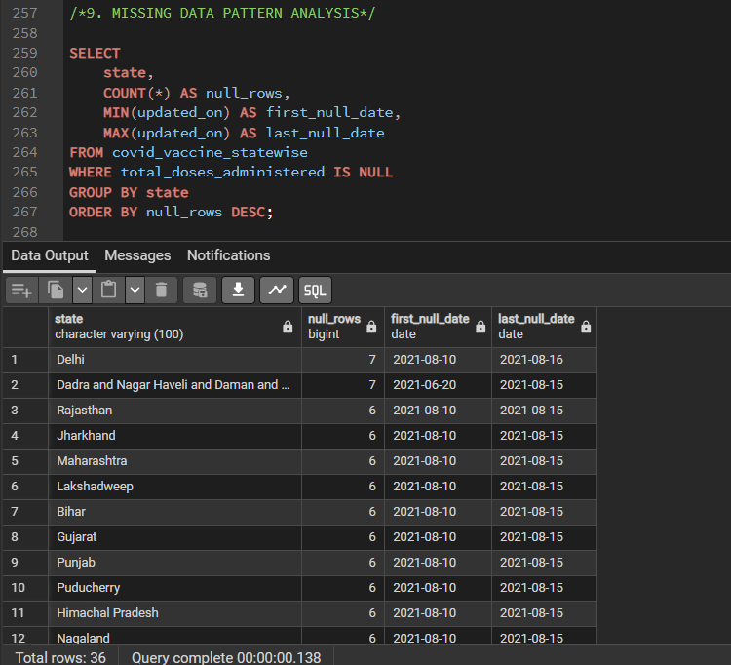

2.3 Transform Phase – Feature Engineering
This phase involved creating calculated metrics required for analysis.
Intermediate tables were created to perform transformations step-by-step.
Intermediate tables created:
- Covid_summary_base
- Covid_summary_with_testing
- covid_summary_with_vaccine
These tables helped in building the final dataset step-by-step and made the process organized and easier to debug.

Unified Confirmed Cases
ConfirmedIndianNational and ConfirmedForeignNational columns were combined into one column:
total_confirmed
This gives total confirmed cases.
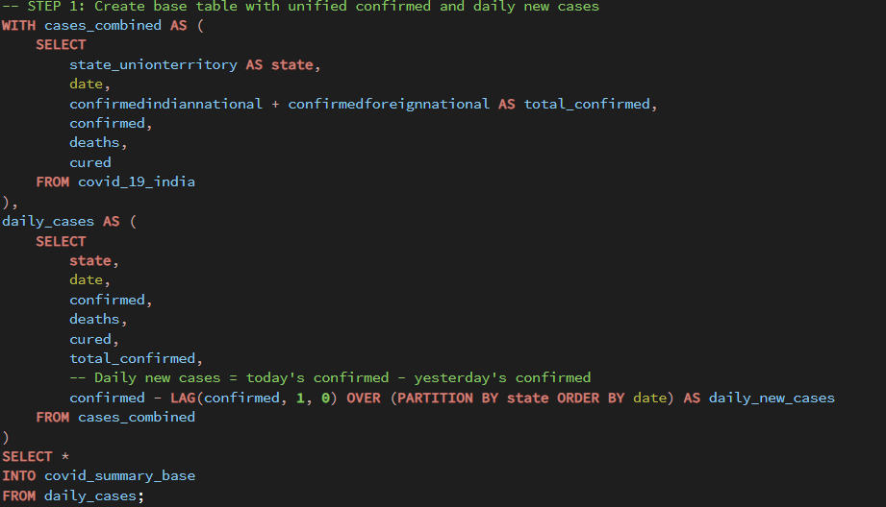

Daily New Cases Calculation
Daily new cases were calculated using LAG window function.
Formula:
Daily New Cases = Today's Confirmed − Previous Day Confirmed
Partition was done by the State.
This helps in analyzing daily growth.
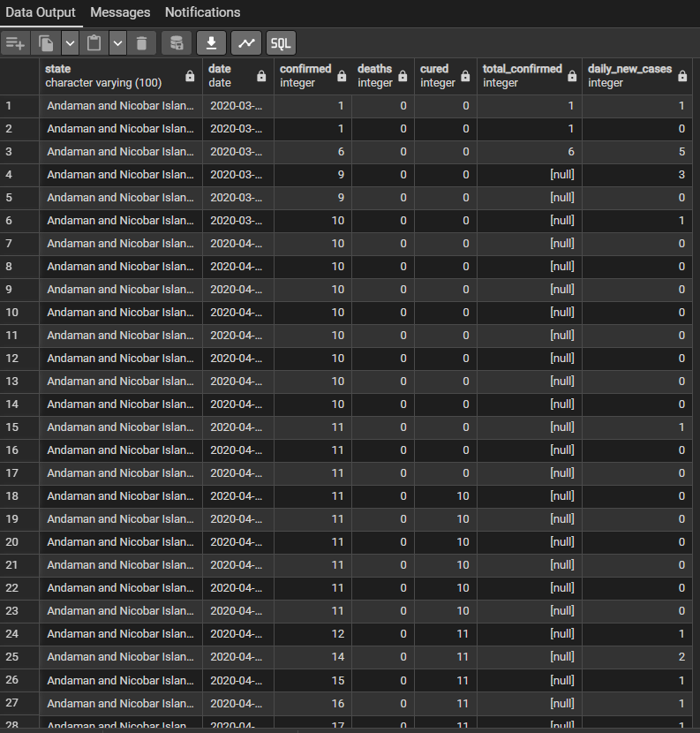

Big Join – Combining Testing Data
Testing data was joined using:
State and Date
This added:
- TotalSamples
- positive
to the dataset.
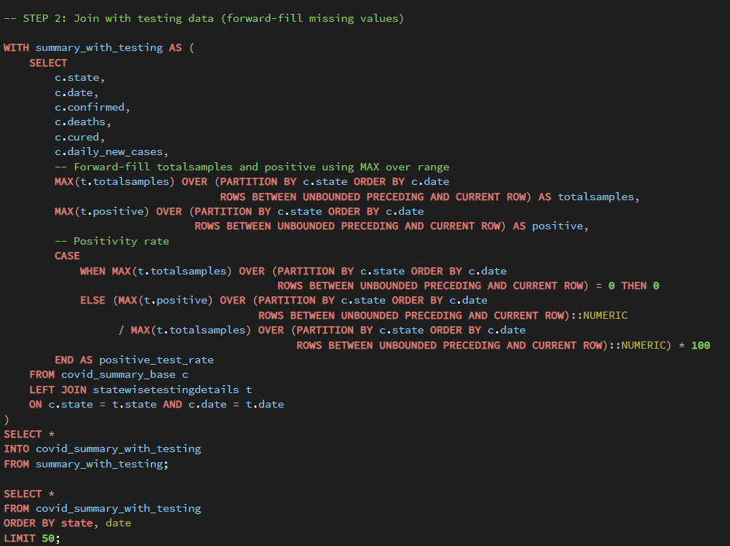
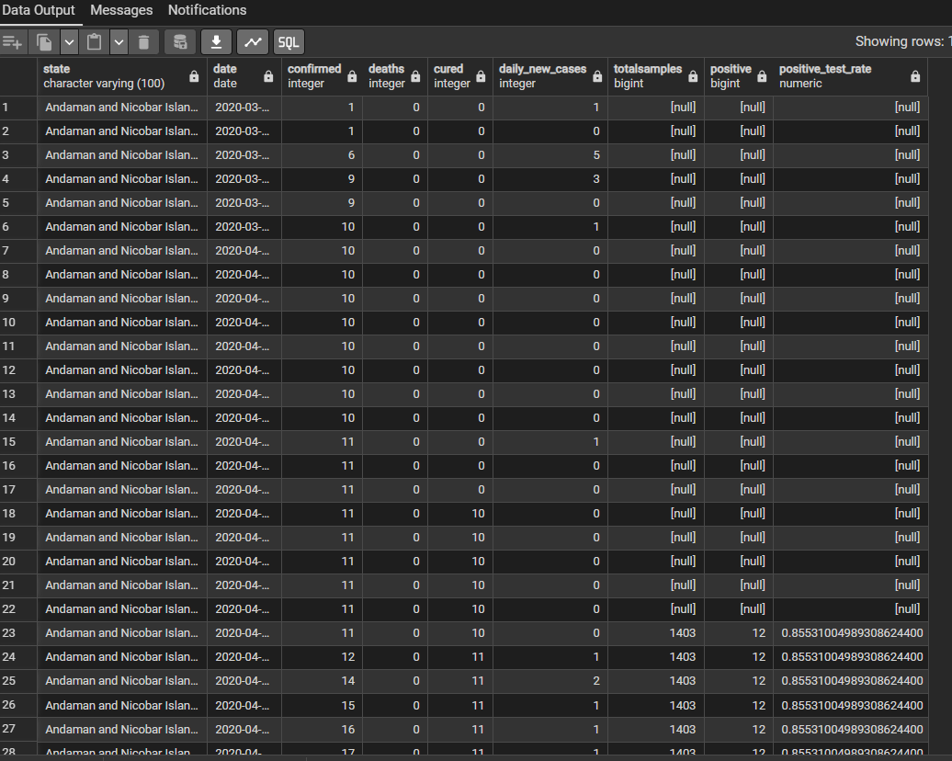

Forward Fill Handling
Testing and vaccination data were not available for every date.
So the forward fill method was used.
Forward fill means:
The previous available value is carried forward until a new value appears.
This was done using:
MAX() OVER (PARTITION BY state ORDER BY date)
This ensures continuous and complete data.
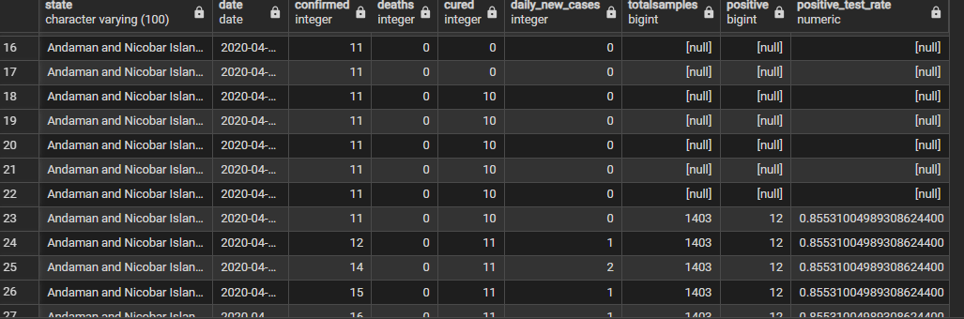

Positive Test Rate Calculation
Formula: Positive Test Rate = Positive / TotalSamples × 100
This shows infection spread level.
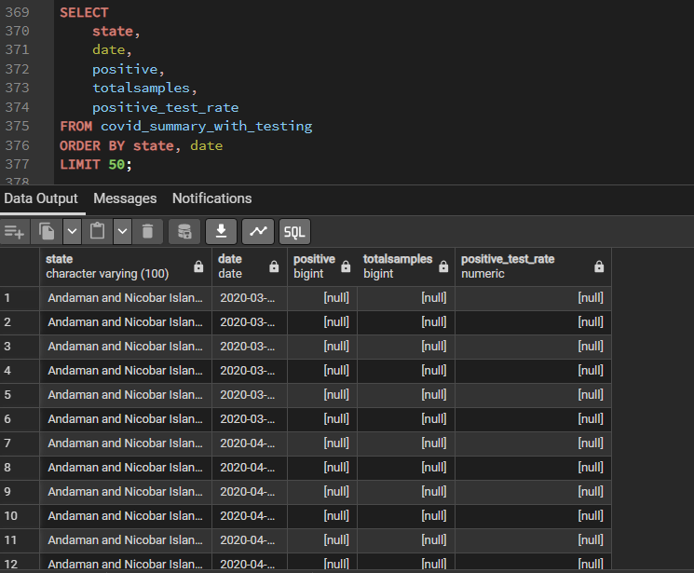

Vaccination Rate Calculation
Population data was added.
Formula:
Vaccination Rate = Total Doses / Population × 100
This shows vaccination progress.
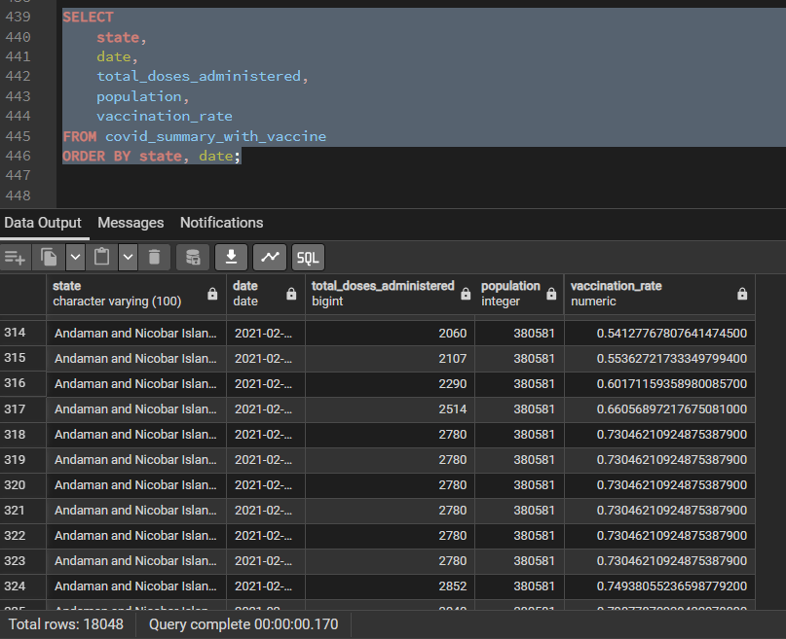

Case Fatality Rate Calculation
Formula:
Case Fatality Rate = Deaths / Confirmed × 100
This shows disease severity.
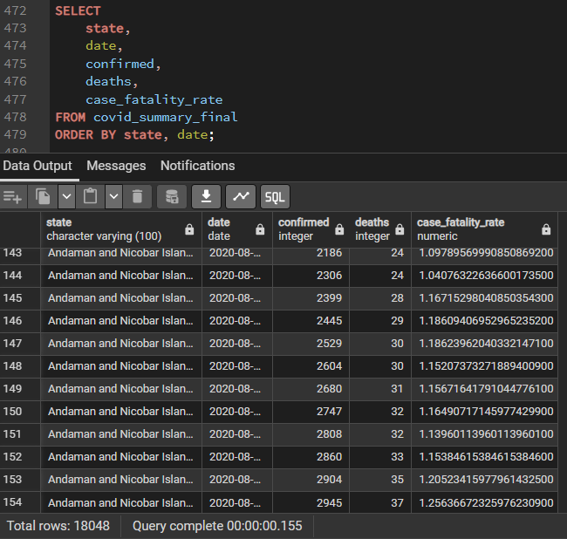

Risk Level Classification
Risk levels were created based on:
- High Risk
- Medium Risk
- Low Risk
Conditions were applied using CASE statements.
This helps identify dangerous states.
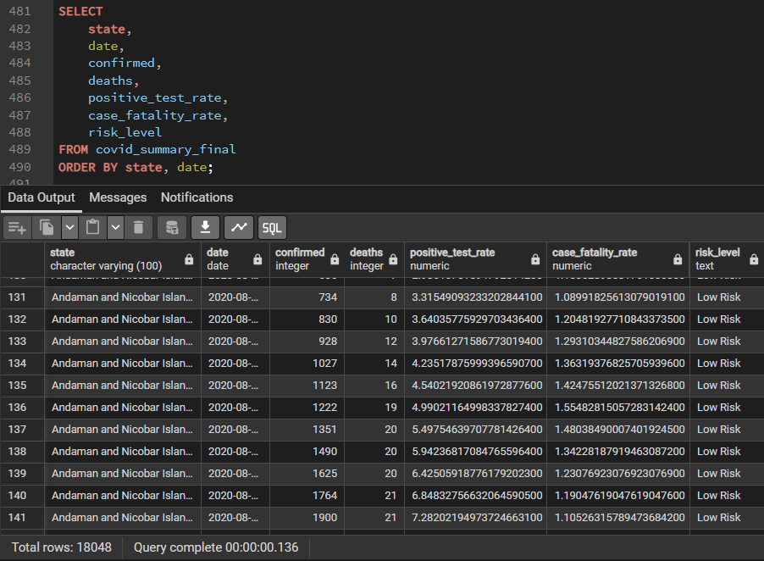

2.5 Final Output Generation
After completing all transformation steps, the final summary table covid_summary_final was created.
This table contains all required metrics for further analysis and visualization.
The final table includes the following columns:
- State
- Date
- Confirmed Cases
- Deaths
- Cured
- Daily New Cases
- Total Samples Tested
- Positive Cases
- Positive Test Rate
- Total Doses Administered
- Population
- Vaccination Rate
- Case Fatality Rate
- Risk Level
This table combines data from all three datasets into a single structured format.
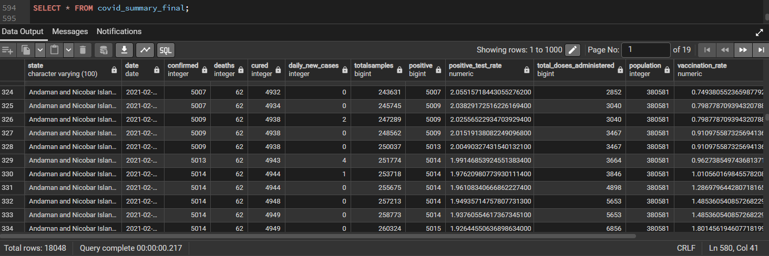

2.6 Data Export
The final table was exported into CSV format using PostgreSQL export functionality.
This file is named:
covid_summary_final.csv
This file will be used by the Excel Team for:
- Statistical Analysis
- Dashboard Creation
- Visualization
- Insight Generation
2.6 Observations
- Early stage data contains missing values
- Testing and vaccination started later
- Duplicate entries were found in raw data
- Forward fill was used to maintain continuous records

2.6 Conclusion of ETL Phase

The ETL process successfully completed the following:

Created structured tables from raw CSV files

Cleaned and standardized data

Combined multiple datasets

Calculated required metrics

Generated final summary table

Exported data for Excel analysis

This final dataset serves as the foundation for further statistical and dashboard analysis.

Section 3: Excel Analysis
1. Data Sources
Three main datasets were imported via Data → From Text/CSV and converted into structured tables (Ctrl + T) to make formula referencing and PivotTable analysis easier:
- SummaryData: Daily confirmed, recovered, deceased, and positive cases.
- VaccineData: Daily cumulative vaccination counts.
- TestingData: Daily state-wise testing sample counts.
2. Data Cleaning and Preparation
- 2.1 Date Normalization: The dates were already formatted correctly from the SQL export, so the format was simply verified instead of requiring manual transformation.
- 2.2 Handling Missing Values: Go To Special → Blanks was used to find empty numeric cells, which were then replaced with 0. This prevented #DIV/0! calculation errors and ensured mathematical consistency.
3. Data Integration (Merging Testing Data)
To merge TestingData into SummaryData (mimicking a database JOIN), a composite key was created to uniquely identify each row:
- =TRIM([@state]) & TEXT([@date],"dd-mm-yyyy")
Next, the TotalSamples data was pulled into the main tracking table using INDEX and MATCH:
- =INDEX(TestingData[TotalSamples], MATCH([@Key], TestingData[Key], 0))
4. Data Validation (Recalculating Daily Cases)
To verify data accuracy, the daily new cases were recalculated to ensure they mathematically matched the running cumulative totals. The OFFSET function was utilized to compare each day's total to the previous day:
- =IF([@state]=OFFSET([@state],-1,0), [@confirmed]-OFFSET([@confirmed],-1,0), 0)
5. Key Metrics Calculation
- 5.1 Positive Rate: Measures testing efficiency and how fast the infection is spreading.
  - =IF([@TotalSamples]=0, 0, [@positive]/[@TotalSamples])
- 5.2 Recovery Rate: Shows the proportion of confirmed cases that successfully recovered.
  - =IF([@confirmed]=0, 0, [@recovered]/[@confirmed])
- 5.3 Cumulative Vaccination Rate: Because vaccine data is a running total, the final recorded value represents total coverage.
  - Pivot Setup: Rows → State | Values → MAX of Total Doses Administered
  - Calculation: MAX_Total_Doses / Population

6. Visualizations and Interpretation

6.1 Positive Rate Trend (Line Chart)
Pivot grouped by Month-Year with Average Positive Rate. This chart identified peaks corresponding to pandemic waves.
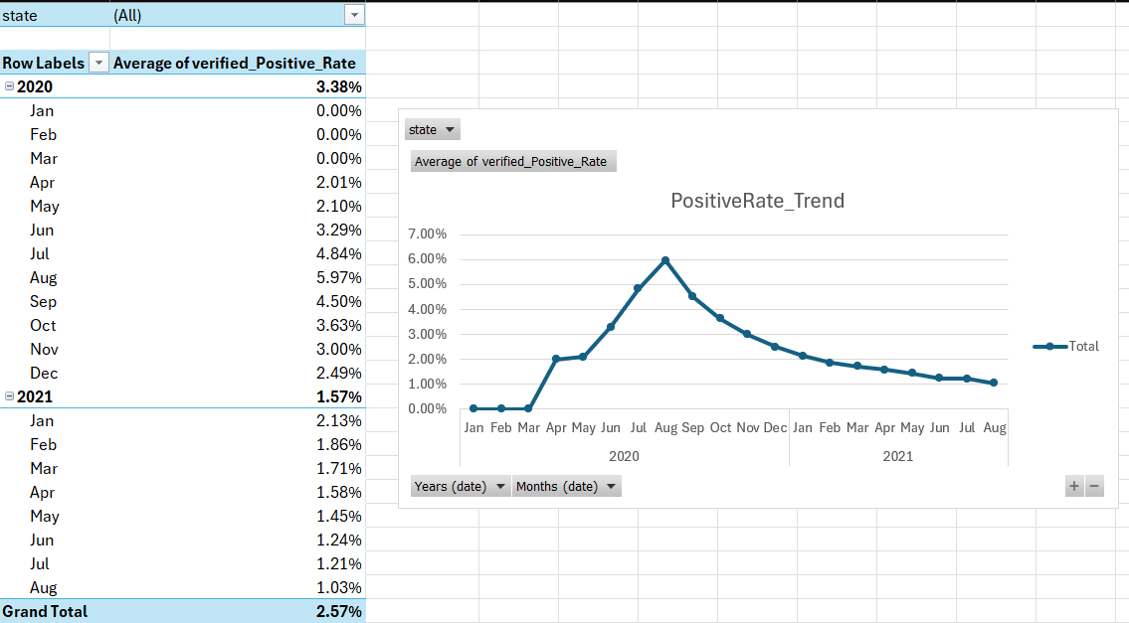

6.2 State Contribution

Pivot with MAX Confirmed cases displayed as % of Grand Total. This highlighted each state's contribution to total infections.
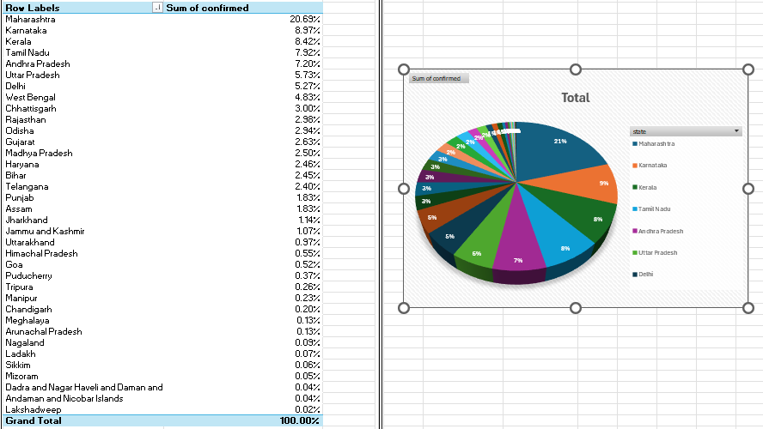

6.3 Monthly Case Trend (Line Chart)
Pivot grouped by Month-Year using SUM of Verified_Daily_Cases. Clear waves were visible over time.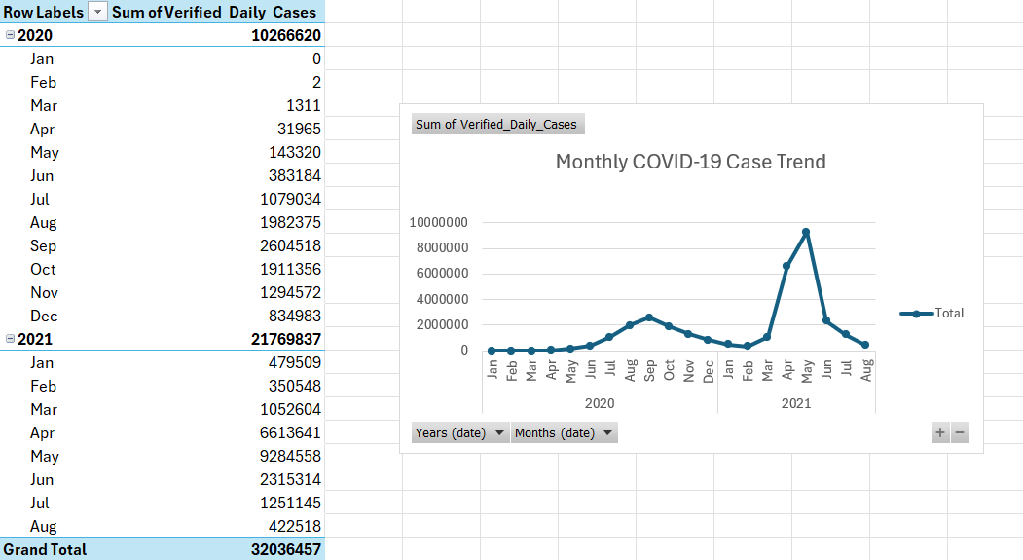

6.4 Heatmap (Average Monthly Cases)
Pivot with Rows → State and Columns → Month-Year using Average Daily Cases. Conditional formatting color scale created a heatmap to highlight hotspots.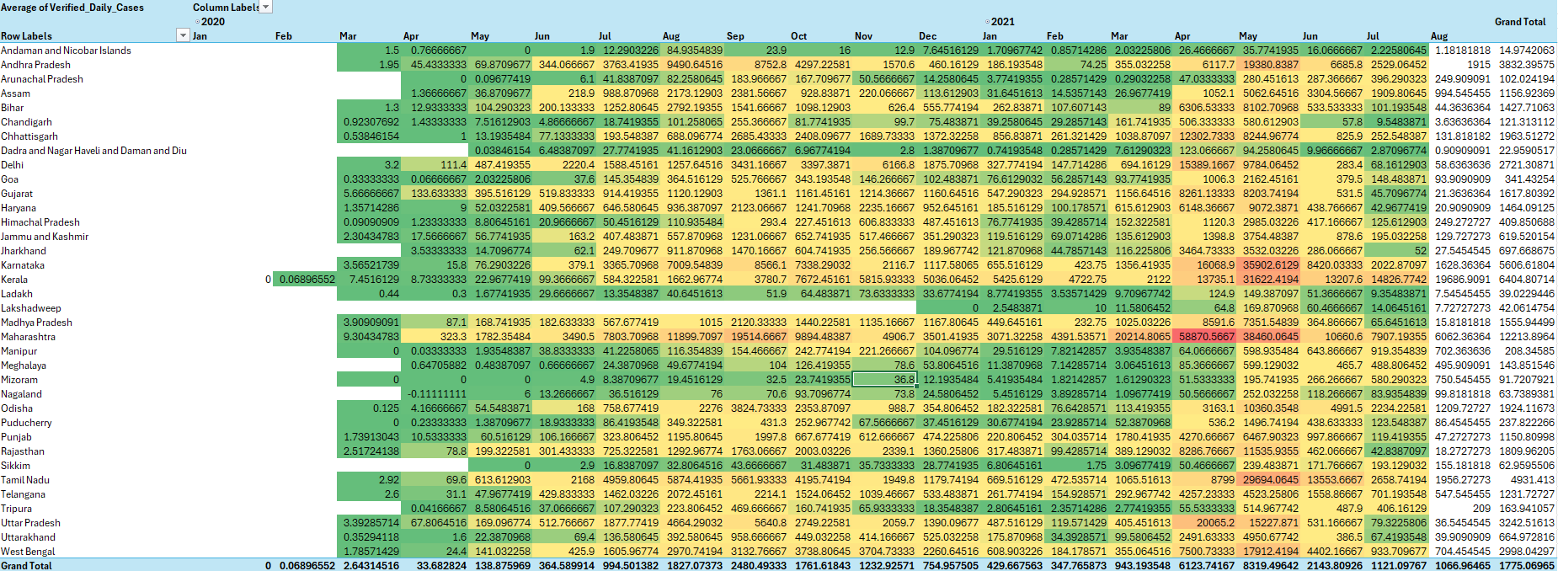

6.5 Age Group Vaccination (Bar Chart)
MAX cumulative doses per age group were calculated and compared. The 18–44 age group showed the highest vaccination count.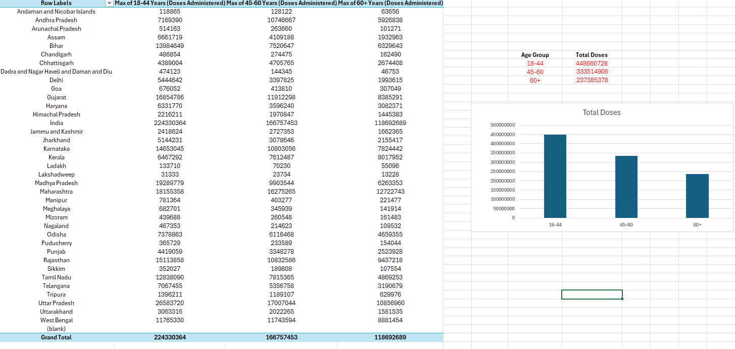

6.6 Top 5 States States ranked using MAX confirmed cases and filtered to Top 5. These states experienced the highest infection burden.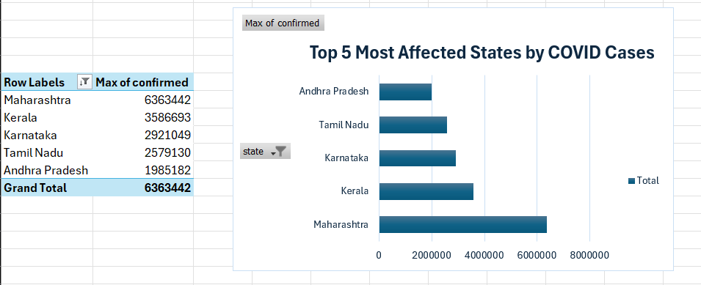

6.7 Vaccination vs Recovery
Pivot used MAX Recovery Rate and MAX Vaccination Rate per state.
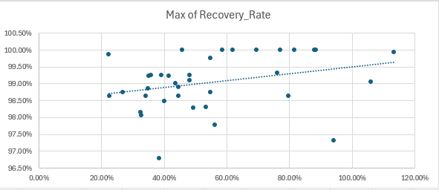

7. Feature Engineering & Logic Tools
Three custom features were engineered to drive the dashboard's logic matrix:
- active_cases: Calculated dynamically as =[@confirmed] - [@cured] - [@deaths].
- excel_risk_level: A nested conditional logic gate calculating severity: =IF([@active_cases]>50000, "High Risk", IF([@active_cases]>10000, "Medium Risk", "Low Risk")).
- day_of_week: Extracted from the timestamp using =TEXT([@date], "dddd") to enable seasonal tracking.

7.1 Advanced Dashboard Modules
- The Date Query Engine: An interactive, two-criteria search tool was engineered using nested boolean arrays. By combining INDEX and MATCH functions (e.g., =MATCH(1, (CovidData[date]=$C$9)*(CovidData[state]=$C$10), 0)), the tool allows users to input any Date and State to instantly retrieve historical confirmed cases and deaths.
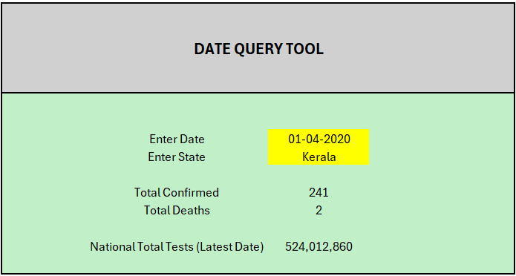
- National Testing Matrix: To calculate the cumulative national tests without double-counting historical running totals, a SUMIFS logic gate was deployed: =SUMIFS(CovidData[totalsamples],CovidData[date],MAX(CovidData[date])).
- Dynamic Critical State Filter: While the project initially scoped a static "Advanced Filter" to extract states breaching a specific Case Fatality Rate (CFR), we engineered a superior solution. Utilizing the dynamic array =FILTER(P4_Data, P4_Data[case_fatality_rate] > $G$2, "No states found"), the dashboard now features a parameterized input box, allowing stakeholders to dynamically adjust the CFR threshold on the fly.
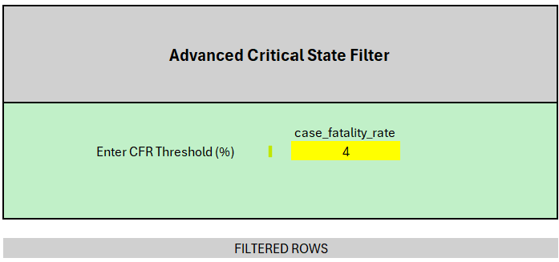

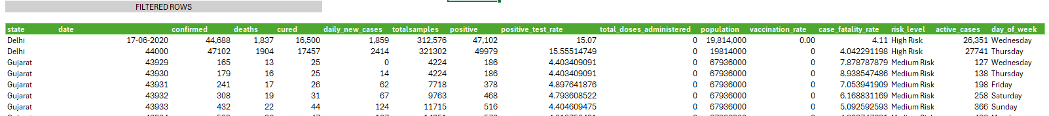

7.2 Analytical Insights & Strategic Recommendations
- Insight 1: Administrative Seasonality (Weekday Analysis)
  - Finding: Pivot table analysis evaluating the average daily cases per weekday revealed a distinct anomaly. While most days averaged between 1,821 and 1,928 cases, Tuesdays consistently showed a pronounced dip to 1,621 cases.
  - Actionable Recommendation: This represents an "administrative lag" caused by reduced testing and reporting lab capacity over the weekend, resulting in an artificial drop in reported numbers on Tuesdays. Healthcare supply chains and hospital staffing must not scale down operations based on Tuesday data, as the viral spread remains constant despite the reporting artifact.

- Insight 2: Predictive Trajectory (Time Series)
  - Finding: Utilizing a single-state isolation method, an Exponential Smoothing (ETS) algorithmic forecast was successfully deployed to project daily new cases 30 days into the future.
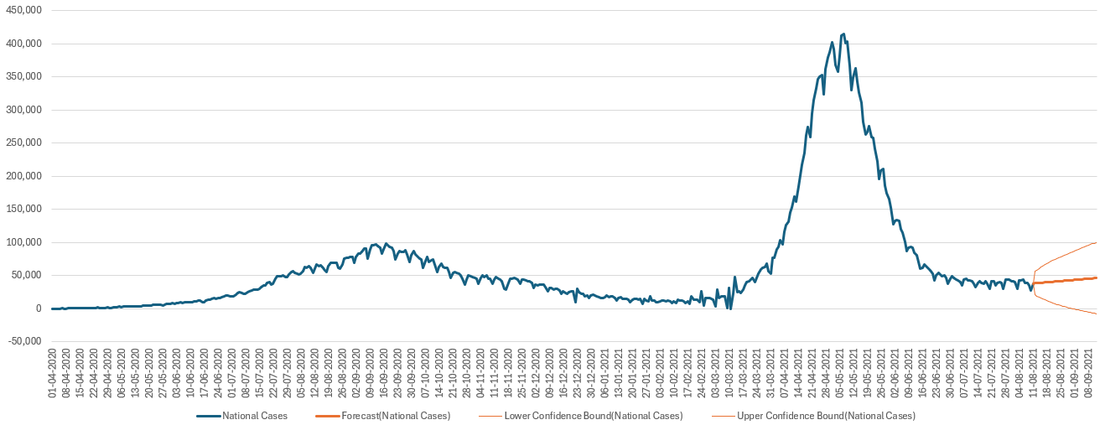
  - Actionable Recommendation: By mapping the 95% confidence intervals generated by this forecast, policymakers can anticipate upper-bound scenarios for hospital bed utilization a full month in advance.

- Insight 3: Dynamic Risk Stratification
  - Finding: The dynamic CFR filtering array successfully identified states with historically critical death rates.
  - Actionable Recommendation: Federal resource allocation (such as ventilators and supplemental oxygen) should be routed using this live, ratio-based severity matrix rather than relying solely on cumulative gross case counts, ensuring aid reaches the most mathematically vulnerable populations first.

Section 4: Interactive Dashboard & State-Specific Analysis (P5)

4.1 Dashboard Architecture & Integration
The final phase of the project involved synthesizing the backend data models, predictive analytics, and static charts from previous phases into a unified, interactive Graphical User Interface (GUI). All disparate datasets (SummaryData, VaccineData) were merged into a single Master Workbook. During integration, external reference errors were resolved by forcefully redirecting the Pivot Caches to the local master tables.

4.2 COVID-19 Analytics Dashboard
To provide policymakers with an immediate, high-level overview of the pandemic's national trajectory, a centralized dashboard was engineered.
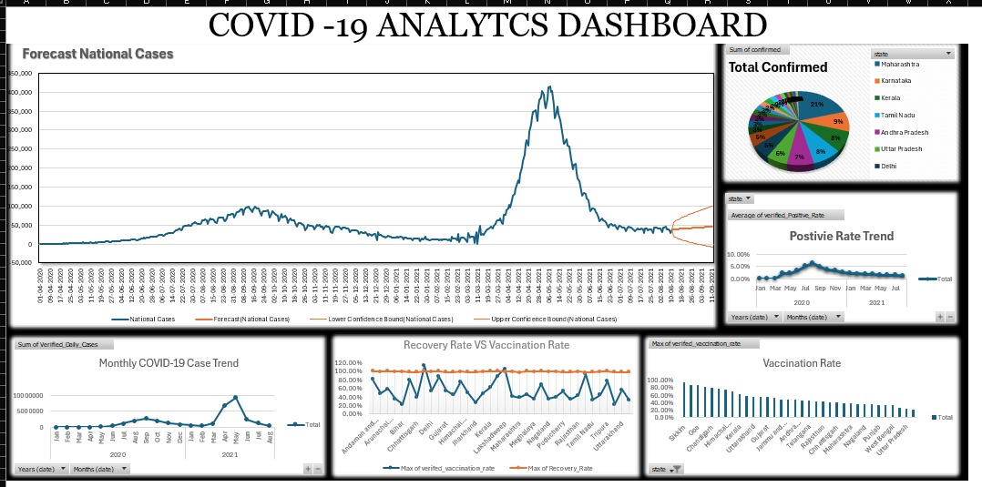
Key Visual Modules Integrated:
- National Predictive Trajectory: The "Forecast National Cases" chart utilizes the Exponential Smoothing (ETS) algorithm to plot the aggregated national daily cases, projecting a future trendline with upper and lower 95% confidence bounds.
- Geospatial Burden: A "Total Confirmed" donut chart visually isolates the states carrying the highest percentage of the national viral burden (e.g., Maharashtra at 21%).
- Temporal Wave Analysis: Line charts mapping the "Positive Rate Trend" and "Monthly Case Trend" clearly visualize the distinct waves of the pandemic.
- Efficacy & Adoption: The dashboard maps the "Vaccination Rate" side-by-side with a "Recovery Rate vs. Vaccination Rate" dual-axis trend, visually correlating vaccine rollouts with improved survival outcomes.

4.3 State-Specific Analysis Module
While the main dashboard provides a national macro-view, a dedicated "State-Specific Analysis" tool was built to allow deep-dive drill-downs into individual regional metrics.
Interactive Engineering Elements:
- Dynamic Parameterization (The Dropdown): A Data Validation list was engineered in cell A2. This allows the user to actively select any of the 36 States or Union Territories (e.g., "Himachal Pradesh").
- KPI Retrieval Engine: Upon selecting a state, a backend array of formulas instantly fetches the localized data:
  - Total Cases & Deaths: SUMIFS formulas were deployed to dynamically aggregate the historical data for the explicitly selected state.
    - Cases Formula: =SUMIFS(SummaryData!C:C, SummaryData!A:A, 'State-Specific Analysis '!A2)
    - Deaths Formula: =SUMIFS(SummaryData!D:D, SummaryData!A:A, 'State-Specific Analysis '!A2)
  - Temporal Sync (Date): To ensure the dashboard reports the most current snapshot, a MAXIFS array isolates the absolute latest recorded timestamp for that specific state.
    - Date Formula: =MAXIFS(SummaryData!B:B, SummaryData!A:A, 'State-Specific Analysis '!A2)
Advanced Multi-Criteria Logic (Risk Level): Standard Excel lookup functions cannot evaluate two criteria simultaneously (e.g., finding the Risk Level for a specific State on a specific Date). To bypass this limitation, an advanced in-memory array was engineered:
- Risk Formula: =VLOOKUP($A$2&$D$2, CHOOSE({1,2}, SummaryData!A:A&SummaryData!B:B, SummaryData!N:N), 2, FALSE)
- Methodology: This formula concatenates the State and Date ($A$2&$D$2) to create a unique composite key. The CHOOSE({1,2}... function dynamically generates a "virtual table" in Excel's memory, allowing the VLOOKUP to accurately fetch the Risk Level from column N without altering the raw dataset structure.
Visual Drill-Down: A localized Bar Chart is dynamically linked to these KPI outputs. As the user cycles through different states in the dropdown, the chart instantly updates to visually compare the Total Cases against the Total Deaths for that specific geographic region.

